Board of Directors  May Election  2021 Application | 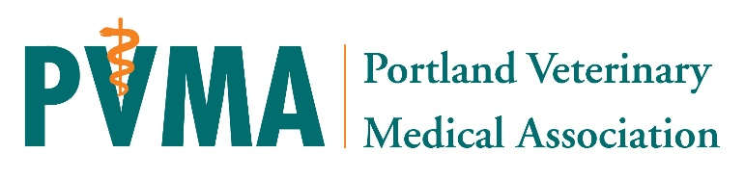
Overview & Expectations | The Board of Directors consists of 7 current PVMA member veterinarians: three (3) Officers, President, President-elect, Treasurer, and four (4) general directors.  Board directors shall be elected by the general membership by way of written ballot. Regular elections are to be held during the regular May meeting for any available seats.  Term: Three (3) years each with the option to renew for a second term with approval from the board.  Meetings: Monthly two hour in-person board meetings held the first Tuesday of each month from 7-9pm. Annual weekend board retreat. Additional committee meetings and one-on-one meetings as needed. Attendance at a minimum of three PVMA general membership meetings or CE events per year is encouraged and help hosting and facilitating events as needed.  Expectations: Board members are expected to attend all board meetings and additionally scheduled in-person meetings as deemed required by the President or Executive Director, and be engaged in, participate in, and contribute to email communication, meetings, and decisions. As board director attendance and participation is critical for effective function of the board, a maximum of 2 absences in a 12 month period is permitted.  Board Chair: Each committee or taskforce will be led by a Board Director Chair. They will direct and lead activities and projects and report directly to the Board of Directors.

Contact Information
Name
Hospital/Practice Name
Cell Phone
Work Phone
E-Mail Address (preferred)

Please tell us why you would like to serve on the PVMA Board of Directors

Whether it is learning more about organized veterinary medicine, giving back to our community, or you have great ideas for ways to grow and improve our organization!

Previous Experience and Special Skills

Summarize your previous volunteer experience: board positions, leadership work, or other skills and qualifications. It is okay if you have limited related experience!

Agreement and Signature

By submitting this application, I affirm that the facts set forth in it are true and complete. I understand that if I am accepted and voted to become an executive board member, I will fulfill my commitment as outlined in the expectations above.

Name (printed)
Signature
Date

Our Policy

It is the policy of this organization to provide equal opportunities without regard to race, color, religion, national origin, gender, sexual orientation, age, or disability.

Thank you for completing this application form and for your interest in becoming more involved with the PVMA!

Please return completed application to the PVMA office via email, fax, or mail by March 25th.
We will confirm receipt and follow-up fully with applicants shortly after.

PVMA
PO Box 6067
Portland, OR 97228
Email: pvma@portlandvma.org
Fax: 503-619-0550
Phone: 503-228-7387

