2021-22  Participation Application | 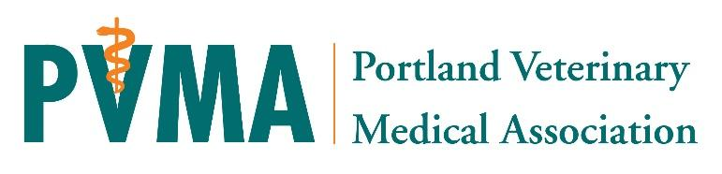
Overview | The Power of 10 program is a personal and professional development program for early-career veterinarians designed to foster resiliency, leadership capacity, collegiality, emotional intelligence, career satisfaction, and longevity in the field.
Eligibility | This program is intended for current PVMA member veterinarians who graduated within the last approximately 8 years (2013-20*); other candidates may be considered based on their level of interest. Enrollment is limited to 10 PVMA members per year. * 2021 graduates may be considered, but it is recommended to complete the intern year prior to participating.
Expectations | Attendance and participation in a year-long program of lectures, panels, discussions, and experiences yielding lifelong, supportive relationships between cohort-members and increased engagement in organized veterinary medicine.  The real backbone of this program is the time spent together and with guest mentors during the sessions. Because of this time commitment, particularly on some weekdays, it is imperative that participants’ employers are aware of and supportive of participation in this program. The PVMA executive director and the facilitators would be happy to support/participate in any conversations with employers or managers to help convey the benefits of your participation in this program.  Absences - A maximum of one absence from a required module will be allowed for legitimate causes only, at the discretion of the program leaders.  The PVMA will provide topic experts, meals, and meeting expenses at no charge to the participant. Most sessions will be held primarily in-person at the PVMA office in SW Portland with possibility of virtual/Zoom format as needed with local and state regulations relating to COVID-19. With your commitment, attendance is considered mandatory.

Applicant Information
Name
Preferred Mailing Address
City, State, Zip Code
Cell Phone
Work Phone
E-Mail Address (preferred)
School Name and Year of Graduation
Employer Hospital/Practice Name
Employment Type (SA, Mixed, Shelter, Residency, etc)
Note | This is a non-competitive application. As a survivor of the vet school application process (and many others), we know you will be tempted to only put the good stuff on this application. Power of 10 is about struggle, growth, and learning - please feel free to be as honest as you like here!  Nothing on this application will be shared with anyone outside of the application selection committee without your express permission.

Goals

Share a little about your medium term or long term career and/or life goals with us - feel free to be as whimsical or practical as you'd like.

Growth

What areas of personal or professional growth are you most excited to explore? Please feel free to provide examples or real life stories that illustrate these areas for growth. This could include (but is not limited to): communication challenges, mental health care, leadership skills, etc.

Professional Commitment

How do you give back or plan to give back to veterinary medicine over the course of your career? Are there any areas that you feel particularly passionate about?

Employer Affirmation – To be signed by your employer (if applicable)
I fully support the enrollment of the above named applicant and commit to supporting their leadership development during the year. I understand that several learning opportunities will take place on work days.
Name (printed)
Signature
Date

Agreement and Signature

By submitting this application, I affirm that the facts set forth in it are true and complete. I understand that if I am chosen as to participate in the Power of 10 program, I will fulfill my commitment as outlined in the expectations above.
Name (printed)
Signature
Date

Our Policy

It is the policy of this organization to provide equal opportunities without regard to race, color, religion, national origin, gender, sexual orientation, age, or abilities.

Thank you for completing this application form and for your interest in participating in the Power of 10!
Please return completed application to the PVMA office via email or mail by August 20, 2021
We will confirm receipt and follow-up fully with applicants shortly after.

PVMA
PO Box 6067
Portland, OR 97228
Email: pvma@portlandvma.org
Fax: 503-619-0550, Phone: 503-228-7387

