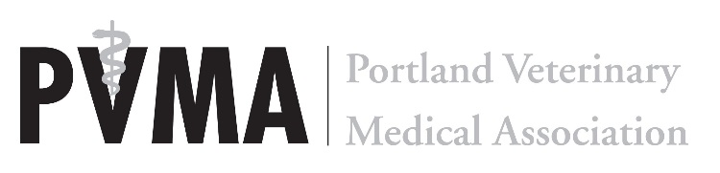
2021 PVMA Awards

This will be the eighth year the PVMA Board of Directors has honored our amazing members and affiliated individuals by recognizing those who have given to our community and profession in exceptional ways. Any current PVMA member veterinarian will be eligible to submit one nomination for each award. Nominations will be accepted through October 15th. Award recipients will be decided by the PVMA Board of Directors and announced at our November General Membership Meeting.

The three award categories are:

- PVMA Veterinarian of the Year (any current PVMA member veterinarian is eligible)
Awarded to a veterinarian who has made exceptional contributions to the profession and the Portland veterinary and animal welfare community through their practice, government appointments or volunteer efforts.

- PVMA Veterinary Team Member of the Year (any non-veterinarian team member is eligible)
Recognition of a veterinary team member that has shown exceptional leadership and dedication in their practice and community.

- Outstanding Service (any allied/affiliated or veterinary professional is eligible)
Honoring an individual, organization or company that has promoted the veterinary profession and the welfare of animals within the Portland metro area through education, research, practice and volunteerism.

We are excited to recognize some of the members of our amazing community. No doubt it will be a difficult decision each and every time!

Complete the form below and include a description of how the nominee is deserving of the award selected above.

Candidate’s Name: ________________________________________________________________________________________

Practice Name: ___________________________________________________________________________________________

Street Address: ___________________________________________________________ City: ____________________________

State: ____________________________ Zip: ____________________________

Phone Number: ___________________________________ Email Address: ___________________________________________

Nominated by: _________________________________________________________________________________

Practice Name: ___________________________________________________________________________________________

Street Address: ___________________________________________________________ City: ____________________________

State: ____________________________ Zip: ____________________________

Phone Number: ___________________________________ Email Address: ___________________________________________

Please attach a paragraph or two sharing with us how the nominee is deserving of the award including any accomplishments, projects and a general description of how exceptional they are!

Please send completed form to the PVMA office: pvma@portlandvma.org, Fax: 503-619-0550, PO Box 6067, Portland, 97206

